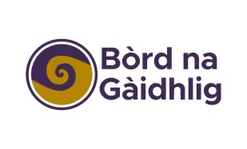
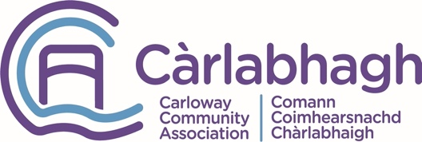

Oifigear Gàidhlig
Gaelic Officer
Job description
Post: Gaelic Officer
Salary: £24,000
Hours: 37 hours per week with some evening/weekend work.
Job-sharing and flexible working will be considered.
Location: Carloway, Isle of Lewis
Contract: Fixed term July 2022-June 2023

Summary
Comann Coimhearsnachd Chàrlabhaigh (CCC) is seeking to recruit a Gaelic Support Officer to work on delivering a comprehensive Gaelic policy and social and cultural activities in the Carloway Community Centre.
Your role will be promoting the use of Gaelic in everyday settings at the refurbished Carloway Community Centre and in the work of Carloway Community Association, provide opportunities to learn the Gaelic language and Gaelic culture and heritage, and engage locals and visitors in Gaelic language and culture.

Main Duties and Responsibilities:

1: Use Gaelic
Using the language in everyday settings at the Community Centre and in the work of CCC.
Outcomes:
- A Gaelic Plan for CCC
- Develop Gaelic signage for use in the Community Centre and Community Shop
- Develop content for web and social media - dual language
- Identify ways in which Gaelic language and culture could offer business and other opportunities in the Community Centre/in the community

2: Learning Gaelic
Provide opportunities and encourage Gaelic speakers to use the language more and share their knowledge with others, and for people to learn the Gaelic language and about Gaelic culture and heritage.
Outcomes:
- Weekly activities to provide opportunities to learn Gaelic– formal and informal settings eg conversational Gaelic Cafes, Gaelic classes for adult beginners
- Monthly activities to provide opportunities to learn about culture and heritage eg Walk and Talks, Information for tourists

3: Support and Promote Gaelic
Engage locals and visitors in the Gaelic language and culture.
Outcomes:
- 2 Exhibitions over the 12-month period in CCC
- 2 events in the CCC Hall involving (local) Gaelic singers, musicians and story tellers, ceilidhs etc.
- Assist local organisations/individuals to access funding/support for Gaelic language development/cultural activities.

Job Criteria
Essential Criteria | Desirable Criteria
Excellent verbal and written communication skills with fluency in Gaelic, both verbal and written. | A degree in Gaelic language, culture, heritage, or related subject.
Experience of heritage/cultural related projects or initiatives. | An awareness of local and national approaches to Gaelic language growth as outlined in relevant Gaelic Language Plans.
Advanced computer skills with knowledge of Microsoft office applications and social media platforms | Website development and editing
Demonstrated organisational and project management skills
Ability to work effectively as a team member and engage with a wide range of community members
Experience of different marketing activities, excellent customer service skills and track record in relationship building | An awareness of business/social enterprises and how language can add value to these.
Ready access to a car and a full, clean driving license.

How to Apply
If you would like to be part of our exciting project in Carloway, send your CV and a covering letter addressing how you meet the selection criteria in the context of the main duties and responsibilities of the job. These should be sent to Mairi Steele using this email link Oifigear Gàidhlig - Gaelic Officer.

The closing date for applications is Monday July 25^{th,} and we hope to hold interviews in the week beginning Monday 1st August.

